

**Operating Systems (OS) – Theory**

**Assignment:01**

**Scheduling Algorithms (Simulation)**

**Submitted by:**

Tayyaba Asif

2019-CE-5

**Submitted to:**

Sir Waqas Ali

**Date:** 11th February, 2022

**Question No.01:**

Compute the response time and turnaround time when running three jobs of length 200 with the SJF and FIFO schedulers.

**Answer:**

Here arrival time of every job is considered to be 0. Since job length is same response time and turnaround time will be same in both cases.

Turnaround Time= Exit Time-Arrival Time

Response Time= Time at which the process gets the CPU-Arrival Time

**Response Time:**

**J1=**0-0=0

**J2=**200-0=200

**J3**=400-0=400

Average response time= $\frac{0+200+400}{3}$ = $\frac{600}{3}$ =200

**Turnaround Time:**

**J1=**200-0=200

**J2=**400-0=400

**J3**=600-0=600

Average turnaround time= $\frac{200+400+600}{3}$ = $\frac{1200}{3}$ =400

**FIFO:**

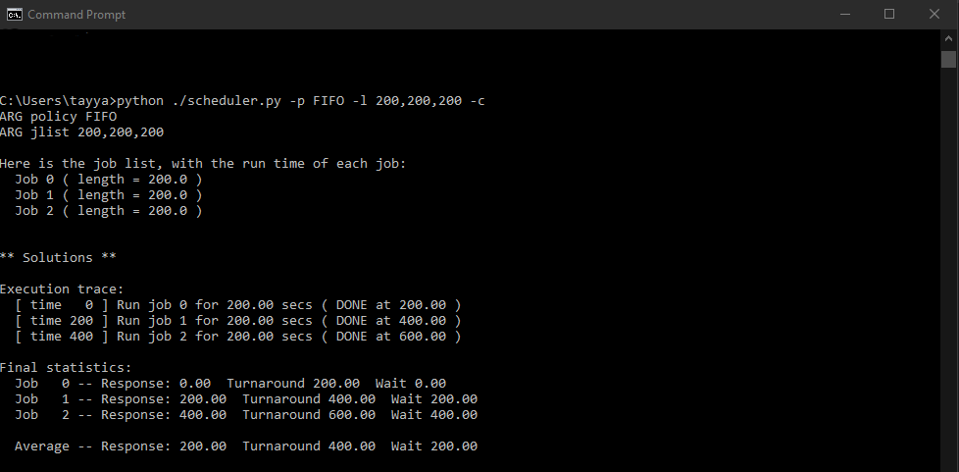

**SJF:**

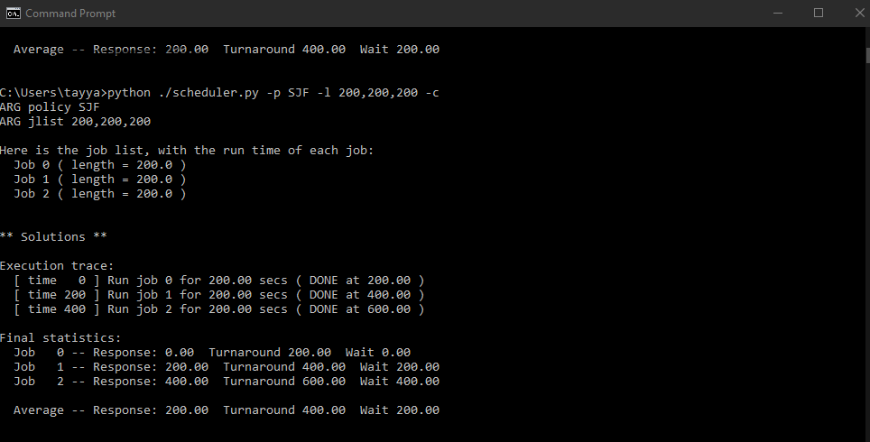

**Question No.02:**

Now do the same but with jobs of different lengths: 200, 100, and 300.

**Answer:**

Here arrival time of every job is considered to be 0.

Turnaround Time= Exit Time-Arrival Time

Response Time= Time at which the process gets the CPU-Arrival Time

**FIFO (First In First Out):**

**Response Time:**

**J1=**0-0=0

**J2=**200-0=200

**J3**=300-0=300

Average response time= $\frac{0+200+300}{3}$ = $\frac{500}{3}$ =166.66

**Turnaround Time:**

**J1=**200-0=200

**J2=**300-0=300

**J3**=600-0=600

Average turnaround time= $\frac{200+300+600}{3}$ = $\frac{1100}{3}$ =366.66

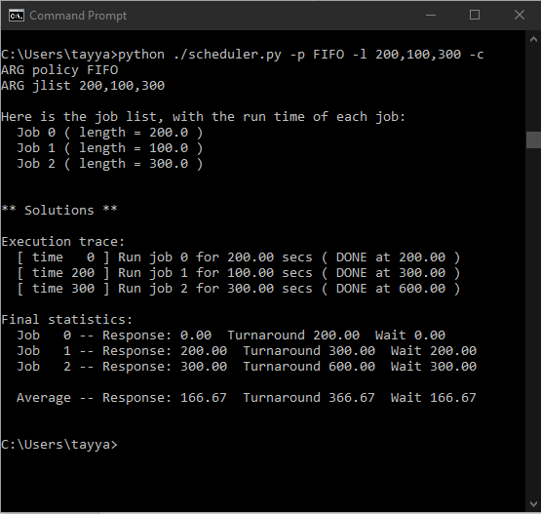

**SJF (Shortest Job First):**

**Response Time:**

**J1=**0-0=0

**J2=**100-0=100

**J3**=300-0=300

Average response time= $\frac{0+100+300}{3}$ = $\frac{400}{3}$ =133.3

**Turnaround Time:**

**J1=**100-0=100

**J2=**300-0=300

**J3**=600-0=600

Average turnaround time= $\frac{100+300+600}{3}$ = $\frac{1000}{3}$ =333.3

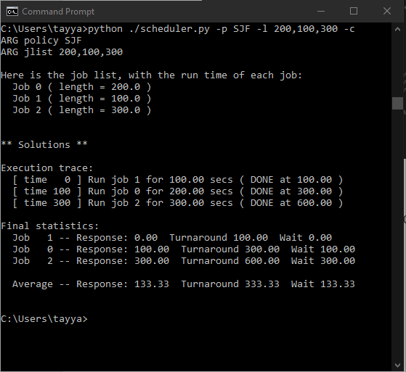

**Question No.03:**

Now do the same, but also with the RR scheduler and a time-slice of 1.

**Answer:**

Here quantum q is given as 1 so it will take so many iterations to complete the process. We can calculate response time easily but turnaround time cannot be calculated easily with small quantum.

**Response Time:**

**J1=**0-0=0

**J2=**1-0=1

**J3**=2-0=2

Average response time= $\frac{0+1+2}{3}$ = $\frac{3}{3}$ =1

**Turnaround Time:**

**J1=**298-0=298 (Exit time is 298 because process gets CPU at 0 and in between switching there are 2 other processes)

**J2=**499-0=499 (Exit time is 499 because process gets CPU at 0 and in between switching there are 2 other processes in start and after completion of J1 only J2 and J3 are left)

**J3**=600-0=600 (Exit time is 600 because process gets CPU at 0 and in between switching there are 2 other processes in start and after completion of J1 and J2 only J3 is left)

Average turnaround time= $\frac{298+499+600}{3}$ = $\frac{1397}{3}$ =465.66

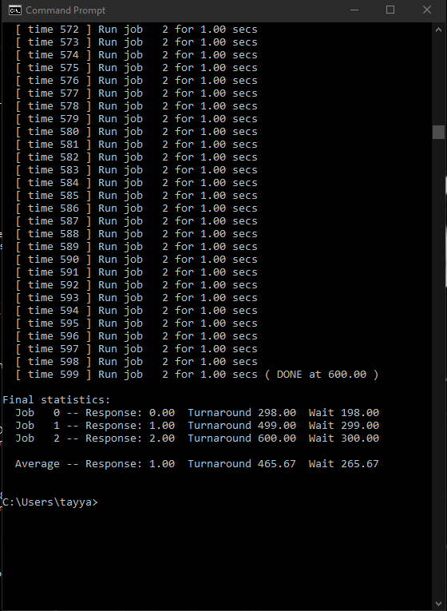

**Question No.04:**

For what types of workloads does SJF deliver the same turnaround times as FIFO?

**Answer:**

Whenever the processes arrive at the same time and they have same length both SJF and FIFO returns the same turnaround time as shown in question number 1.

**Question No.05:**

For what types of workloads and quantum lengths does SJF deliver the same response times as RR?

**Answer:**

Whenever quantum ‘q’ becomes equal to the length of process SJF and RR returns the same response time.

**Question No.06:**

What happens to response time with SJF as job lengths increase? Can you use the simulator to demonstrate the trend?

**Answer:**

When length of the job increases, the response time also increases. This is shown in the screenshots below.

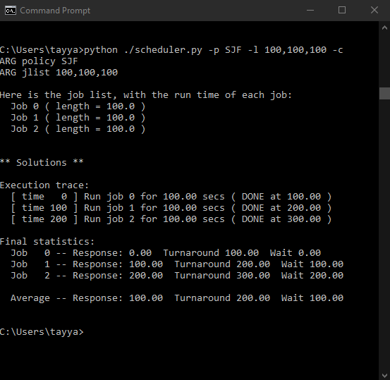

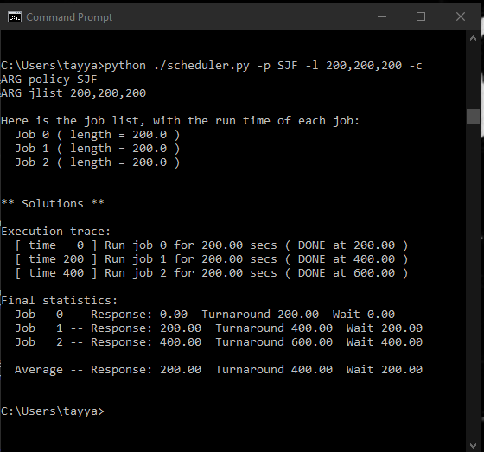

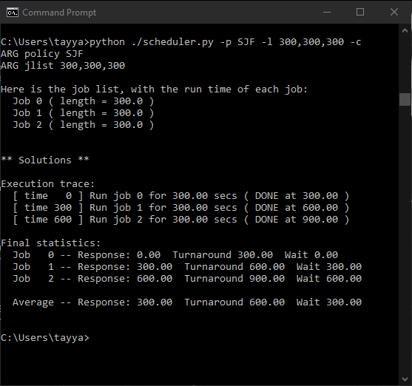

**Question No.07:**

What happens to response time with RR as quantum lengths increase? Can you write an equation that gives the worst-case response time, given N jobs?

**Answer:**

When quantum length is increased, response time of Round Robin (RR) also increases. For the worst-case response time $\frac{\left(N-1\right)*q}{N}$ can be used.

